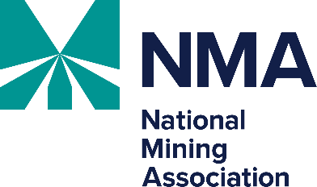
NMA Uranium Recovery Workshop

Sponsorship Opportunities

May 28-29, 2026

Hilton Denver City Center

Sponsorship information for the NMA Uranium Recovery Workshop is detailed below. Please return by Friday, May 1, 2026. Sponsorships are on a first come, first served basis.

Authorized by: ________________________________________________________________

Name: ______________________________________________________________________

Title: _______________________________________________________________________

Company: ___________________________________________________________________

E-mail: _____________________________________________________________________

Please return by Friday, May 1, 2026, to Katie Coon at kcoon@nma.org.
Thank you for your support of the NMA Uranium Recovery Workshop.

