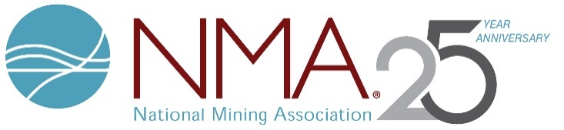

**NMA Executive Committee**

**Virtual Meeting**

**Attendees**

**June 29, 2020**

**Chairman**

Phillips Baker

Hecla Mining

**Vice Chairman**

Jimmy Brock

CONSOL Energy Inc.

**President and CEO**

Rich Nolan

**Members**

Red Conger

Freeport-McMoRan Inc.

Joseph Craft

Alliance Resource Partners, L.P.

Jeff Dawes

Komatsu Mining Corp.

Steve Gottesfeld

Newmont

Denise Johnson

Caterpillar Inc.

Glenn Kellow

Peabody

Mitch Krebs

Coeur Mining, Inc.

Paul Lang

Arch Resources Inc.

Catherine Raw

Barrick Gold Corp.

Walt Scheller

Warrior Met Coal, Inc.