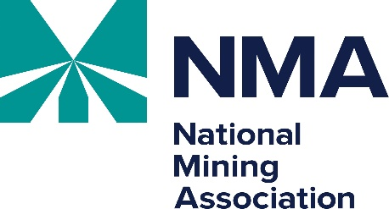

Uranium Recovery Workshop
May 28-29, 2026

Thursday, May 28, 2026
All meetings are in the Hilton Denver City Center, Penrose Ballroom, unless otherwise noted.
The reception on Thursday evening will be in Mattie Silks.
Lanyards sponsored by Petrotek Corporation
8:30 a.m. Registration and Breakfast

9:00 a.m. Welcome
Katie Sweeney, Executive Vice President and COO, National Mining Association

9:15 a.m. Nuclear Regulatory Commission (NRC) Update
Speaker(s) TBD

9:45 a.m. Wyoming Department of Environmental Quality’s Uranium Recovery Program
Charlee Boger, Land Quality Division, Wyoming DEQ

10:15 a.m. Uranium Markets
Scott Melbye, Executive Vice President, Uranium Energy Corp.

10:45 a.m. Break

11:00 a.m. Department of Energy (DOE) Office of Legacy Management
Mary Young, DOE Office of Legacy Management

11:30 a.m. Multijurisdictional Challenges in Conducting Closure/Cleanup Under CERCLA
Chad Baker, Holland & Hart

Noon Lunch (on your own)

1:30 p.m. Update on ANSI N13.8 Revision "Radiation Protection in Mining"
Jan Johnson

2:00 p.m. Idaho National Laboratory Report, Reevaluation of Radiation Protection Standards
Seth Kanter, Idaho National Lab

2:30 p.m. Communicating to the Public on Implications of LNT
Steven Brown
3:00 p.m. Break

3:15 p.m. LNT/ALARA Panel
Seth Kanter/ Steven Brown/ Jan Johnson

4:45 p.m. Wrap-up for Day 1

5:00 p.m.- Reception in honor of Tony Thompson and Chris Pugsley (All registrants invited)
6:30 p.m. Sponsored by WWC Engineering

Uranium Recovery Workshop
May 28-29, 2026

Friday, May 29, 2026
All meetings are in the Hilton Denver City Center, Penrose Ballroom, unless otherwise noted.
Lanyards sponsored by Petrotek Corporation

8:30 a.m. Breakfast

9:00 a.m. Technical Partnership: Department of Energy/National Labs and UR-Energy (Panel)
Representatives from UR-Energy, Los Alamos National Lab, Idaho National Lab, Oakridge National Lab, Pacific Northwest National, and Brookhaven National Lab

10:30 a.m. Break

10:45 a.m. EPA Office of Mountains, Deserts and Plains’ Action on Abandoned Uranium Mines
David Hockey, Director, U.S. Environmental Protection Agency, Office of Mountains, Deserts, and Plains

11:15 a.m. Permitting and Reporting Requirements for Radon Emissions under 40 CFR Part 61
TBD, U.S. EPA

11:45 a.m. DISA Technologies, Inc. Service Provider License
Steve Cohen, Chief Regulatory Affairs Officer, DISA Technologies, Inc.

12:15 p.m. Wrap-up for Day 2

12:30 p.m. Adjournment

